

**LA GRANDEE INTERNATIONAL COLLEGE**

**Simalchaur, Pokhara, Nepal**

Assignment IV

**Submitted to**

Mr. Ashwin Poudel

La Grandee International College

Bachelor of Computer Application (BCA) Program

**Submitted by**

|  |  |  |  |
| --- | --- | --- | --- |
| **Name:** | **Course** | **Semester** | **P.U. Registration Number** |
| Namrata Bastola | BCA | 6th | 2022-1-53-0129 |

**Date: 29th May 2025**

1. **Question(a)**

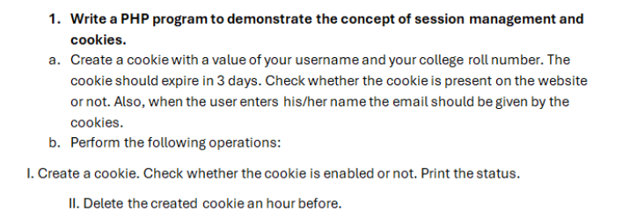

**1.**

1. **a_cookie_form.php**

<?php

// Set a cookie with username and roll number, valid for 3 days

$username = "Namrata";

$roll = "BCA2079F01";

$cookieValue = $username . "|" . $roll;

setcookie("user_info", $cookieValue, time() + (3 * 24 * 60 * 60), "/"); // 3 days

// Check if the cookie is set

$cookieMessage = isset($_COOKIE["user_info"])

    ? "Cookie is set: " . $_COOKIE["user_info"]

    : "Cookie is not set.";

?>

<!DOCTYPE html>

<html>

<head>

    <title>Cookie Demo</title>

</head>

<body>

    <h3>Cookie Status</h3>

    <p><?php echo $cookieMessage; ?></p>

    <h3>User Form</h3>

    <form method="post">

        <label>Name: <input type="text" name="name" required></label><br><br>

        <label>Email:

            <input type="email" name="email"

                value="<?php

                    // Autofill email using cookie data if set

                    if (isset($_COOKIE["user_info"])) {

                        $parts = explode("|", $_COOKIE["user_info"]);

                        echo strtolower(trim($parts[0])) . "@college.edu.np";

                    }

                ?>"

                required>

        </label><br><br>

        <button type="submit">Submit</button>

    </form>

    <?php

    // Show submitted data if form is posted

    if ($_SERVER["REQUEST_METHOD"] === "POST") {

        echo "<h3>Submitted Data</h3>";

        echo "Name: " . htmlspecialchars($_POST["name"]) . "<br>";

        echo "Email: " . htmlspecialchars($_POST["email"]);

    }

    ?>

</body>

</html>

**ii.b_cookie_session.php**

<?php

session_start(); // Start the session

// Part I: Create a cookie and check if cookies are enabled

setcookie("test_cookie", "cookie_value", time() + 3600); // Cookie expires in 1 hour

$cookieStatus = "Unknown";

// Check for presence of any cookies or specifically the test cookie

if (count($_COOKIE) > 0 || isset($_COOKIE['test_cookie'])) {

    $cookieStatus = "Cookies are enabled.";

} else {

    $cookieStatus = "Cookies are disabled or not set.";

}

// Store form-submitted data in the session

if ($_SERVER["REQUEST_METHOD"] === "POST") {

    $_SESSION["name"] = $_POST["name"];

    $_SESSION["email"] = $_POST["email"];

}

// Part II: Delete the test cookie by setting its expiration in the past

setcookie("test_cookie", "", time() - 3600); // Expire 1 hour ago

?>

<!DOCTYPE html>

<html>

<head>

    <title>Cookie Status</title>

</head>

<body>

    <h3>Cookie Check:</h3>

    <p><?php echo $cookieStatus; ?></p>

    <h3>User Form</h3>

    <form method="POST">

        <label>Name: <input type="text" name="name" required></label><br><br>

        <label>Email: <input type="email" name="email" required></label><br><br>

        <button type="submit">Submit</button>

    </form>

    <h3>Session Info:</h3>

    <p>Name: <?php echo $_SESSION["name"] ?? 'N/A'; ?></p>

    <p>Email: <?php echo $_SESSION["email"] ?? 'N/A'; ?></p>

</body>

</html>

1. **send_mail.php**
2. <?php
3. if ($_SERVER["REQUEST_METHOD"] === "POST") {
4. // Collect form data
5. $to = "ramontiwari086@gmail.com"; // Replace with actual receiver email
6. $subject = $_POST["subject"];
7. $message = $_POST["message"];
8. $from = $_POST["email"];
9. $headers = "From: $from";
10. // Send mail
11. if (mail($to, $subject, $message, $headers)) {
12. $status = "Email sent successfully!";
13. } else {
14. $status = "Failed to send email.";
15. }
16. }
17. ?>
18. <!DOCTYPE html>
19. <html>
20. <head>
21. <title>PHP Mail Demo</title>
22. </head>
23. <body>
24. <h2>Send Email (PHP Native mail())</h2>
25. <?php if (!empty($status)) echo "<p>$status</p>"; ?>
26. <form method="POST">
27. <label>Your Email:
28. <input type="email" name="email" required>
29. </label><br><br>
30. <label>Subject:
31. <input type="text" name="subject" required>
32. </label><br><br>
33. <label>Message:<br>
34. <textarea name="message" rows="5" cols="40" required></textarea>
35. </label><br><br>
36. <button type="submit">Send</button>
37. </form>
38. </body>
39. </html>

**3.Snapshots**

**1.i.**

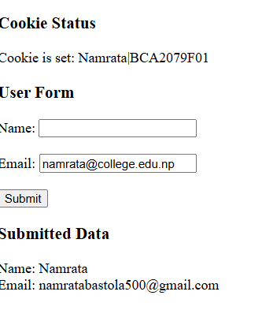

**1.ii.**

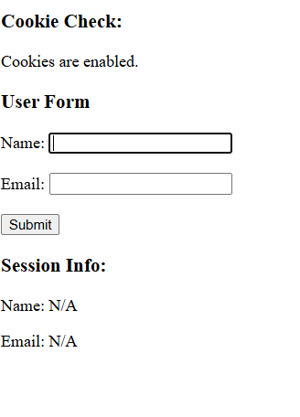

**4.Github Repo(https://github.com/Namrataaa14/WEB-II.git)**